
FATIMA JINNAH WOMEN UNIVERSITY
RAWALPINDI
Department of Software Engineering

SUBJECT: CLOUD COMPUTING

ASSIGNMENT

Name: Saira Ejaz

Reg No: 2023
-
BSE
-
057

Section: 5
-
B

Submitted To:
P
rof. Waqas Saleem

Date:
16
-
10
-
2025

Assignment:
Git, Gitea, GitHub, LFS, and GitHub Pages
Instructions
- Complete all tasks as described below.
- Submit your work on Google Classroom as well as on your GitHub repository named cc_<studentname>_<rollnumber>.
- Ensure all repositories are public unless specified otherwise.
- Submit required links/screenshots in your final submission.
Task List
- Task 1: Run Gitea in Codespace and Create an Initial Repo
- Task 2: Mirror README.md from Gitea to GitHub
- Task 3: Use Git LFS for Large Files
- Task 4: Create a Portfolio/CV with GitHub Pages
- Submission Checklist

Task no 1
Set up Gitea:
- Run a Gitea server inside your Codespace.
  - Create a new codespace
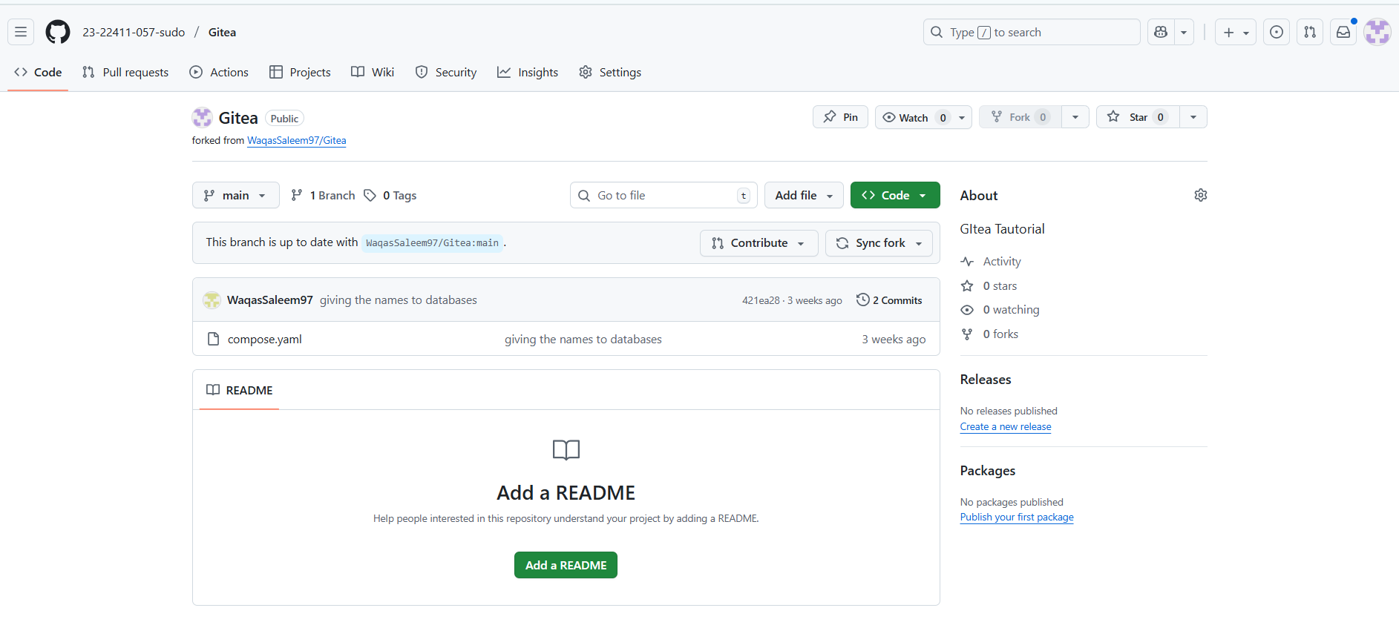
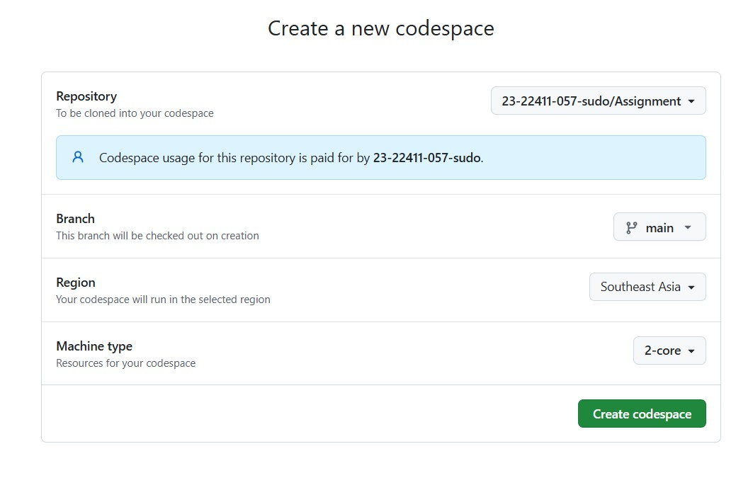
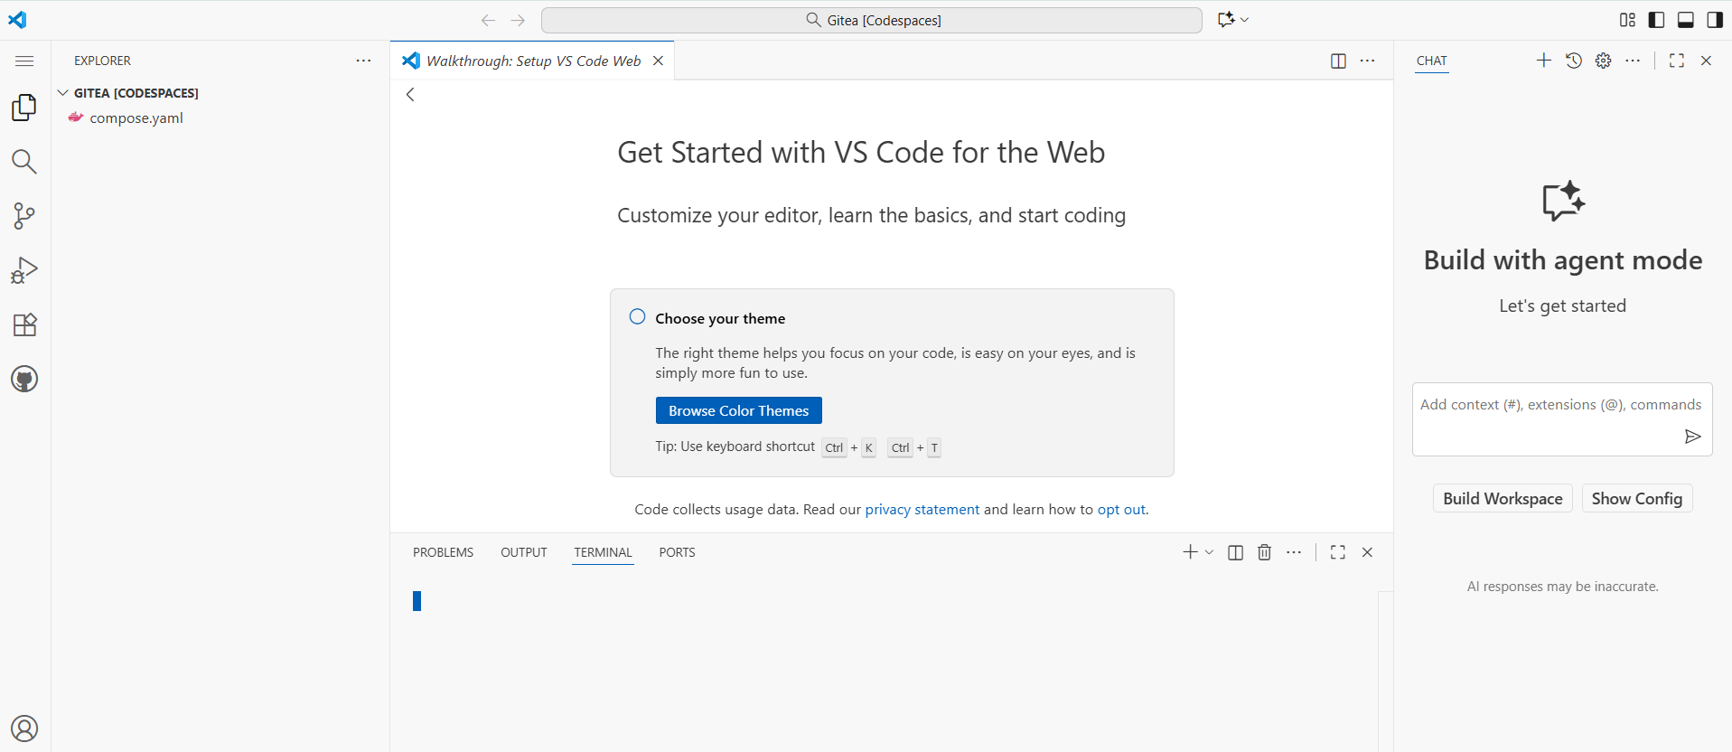
  - Open terminal inside Codespace
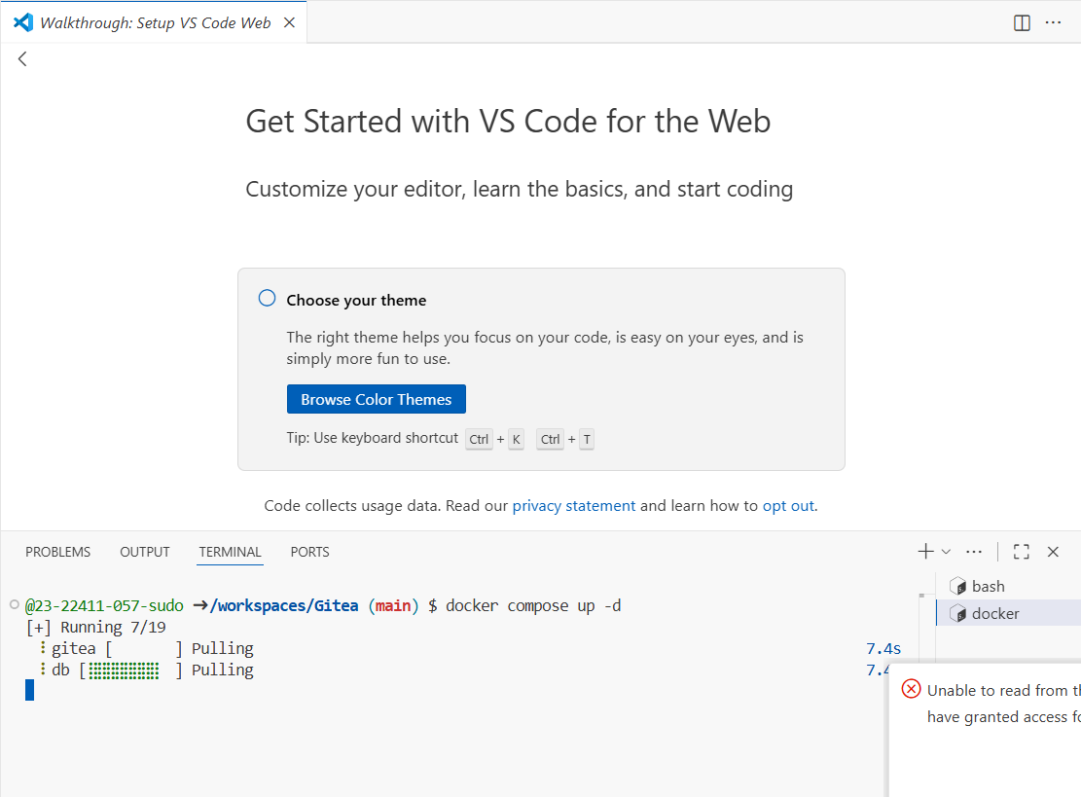

Codespace under this repository:
https://github.com/23-22411-057-sudo/Gitea
https://fluffy-pancake-69x9r4r4jx4w3j4p-3000.app.github.dev/Saira-057/Gitea_Test/src/branch/main/
  - Gitea Installation
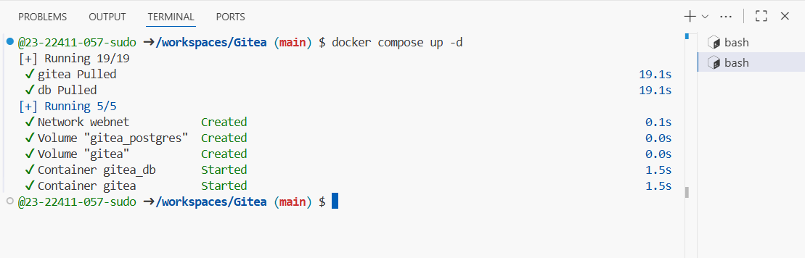
  - Open port inside the codespace and run the url through which gitea will open
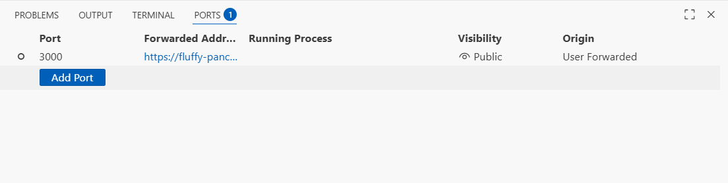
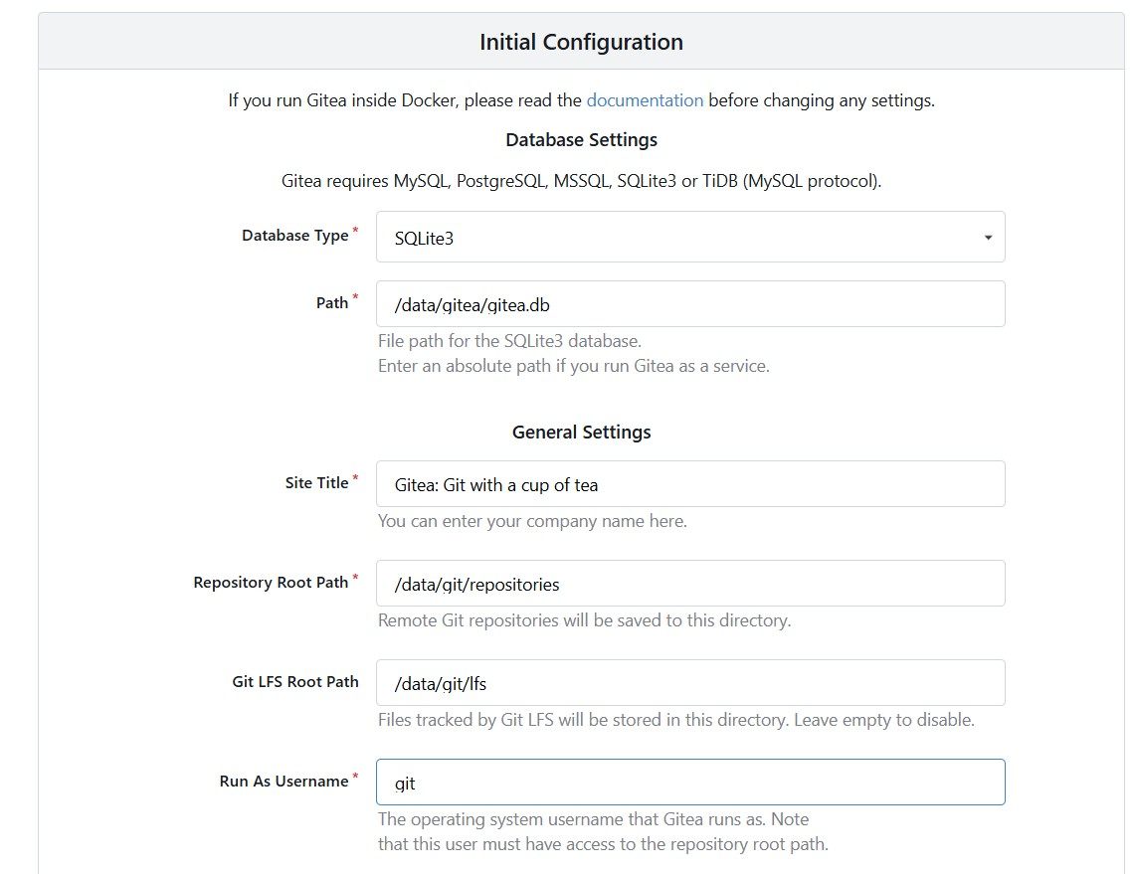

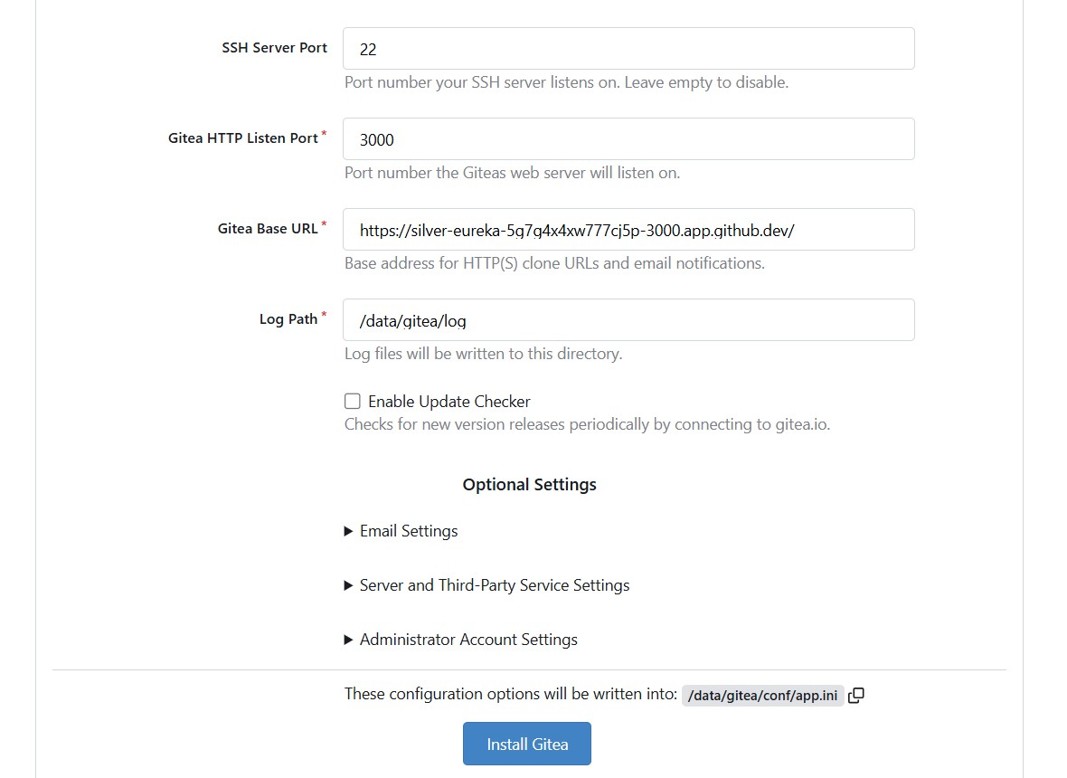
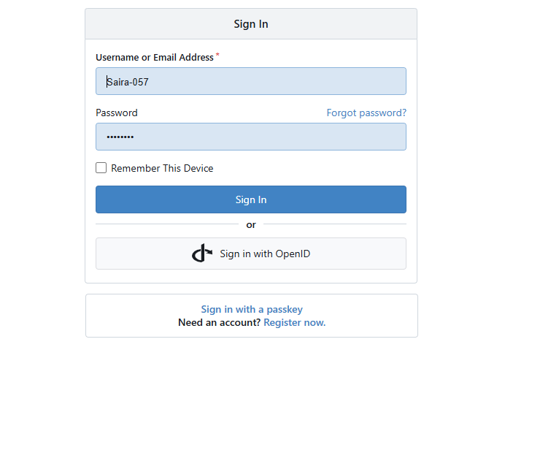
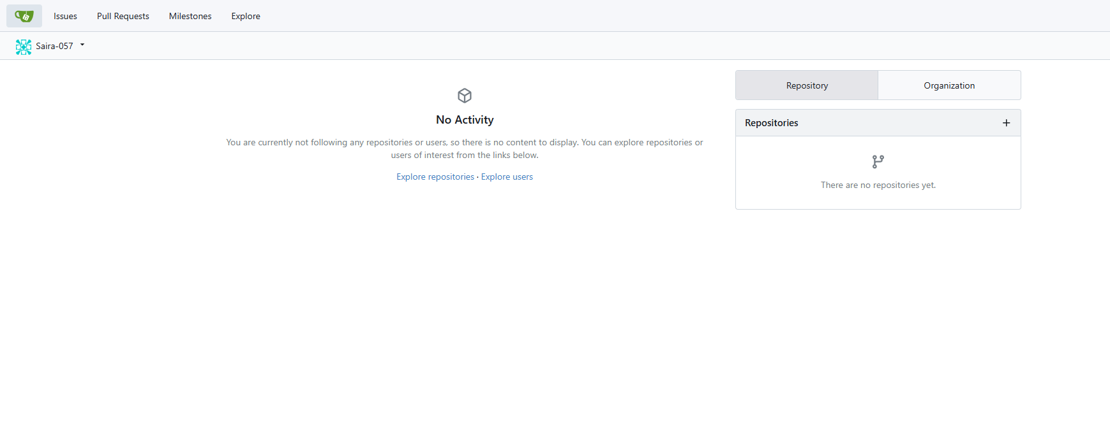
  - Initialize the repository
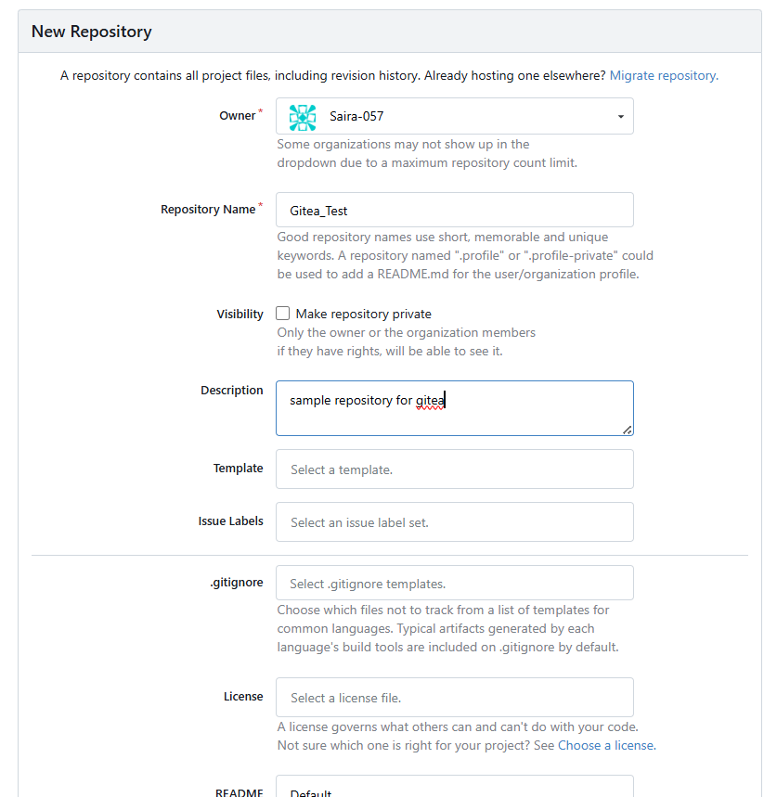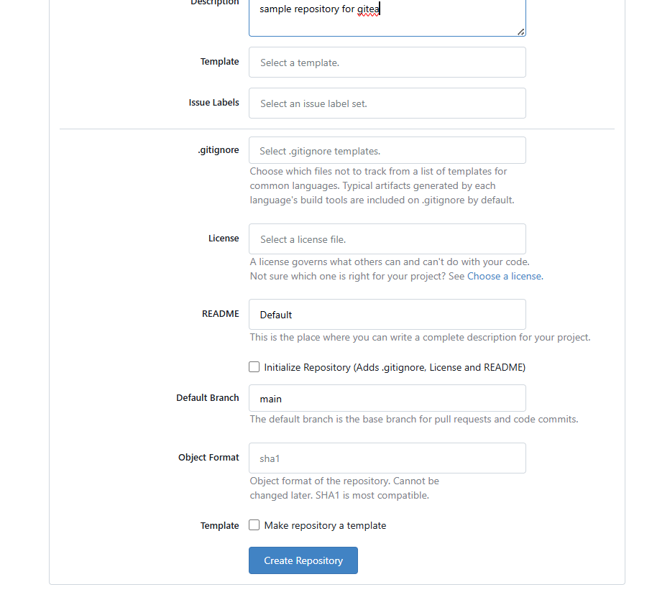
- Use HTTPS for communication (SSH is not supported in Codespace).
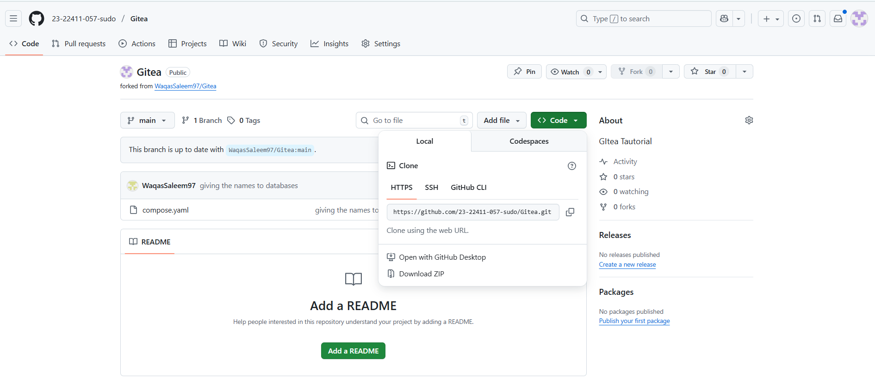
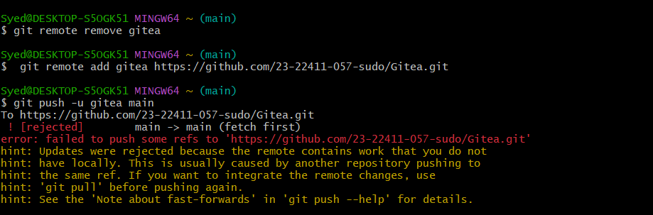
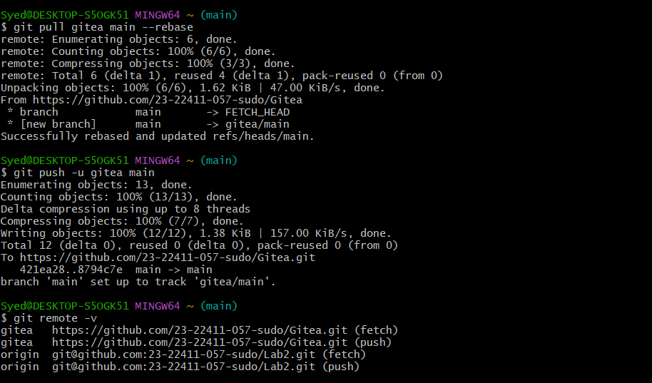
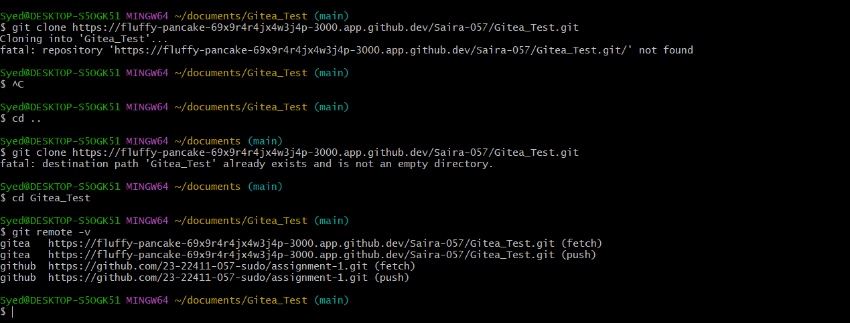
Create a Repository:
- Create a new repository on your Gitea server.

- Add a README.md file listing each student's name and roll number.
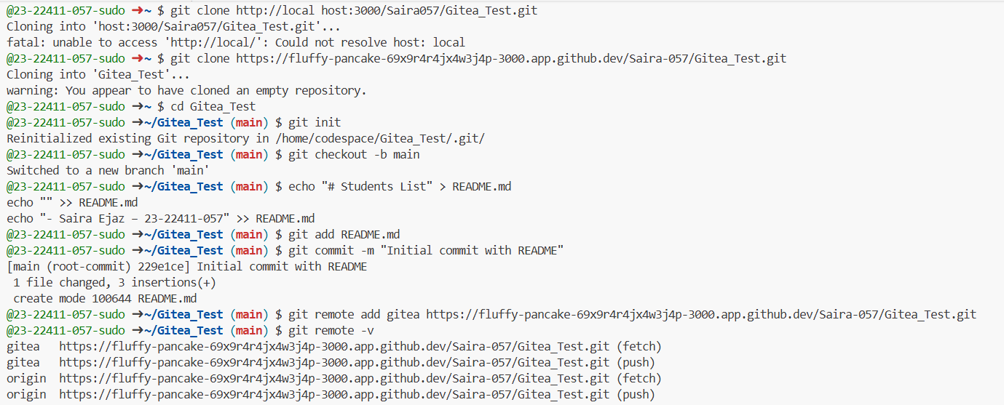

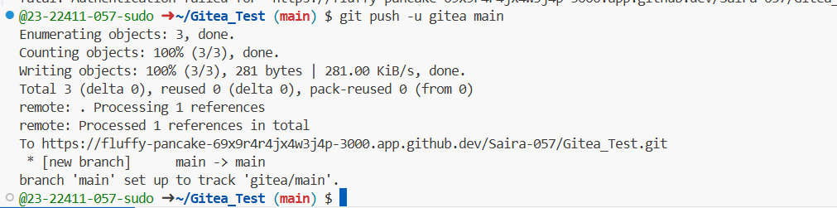

Add Remote Repo:
- Use the following command to add your Gitea repository as a remote:
- git remote add gitea <your_gitea_repo_https_url>
- Push your initial commit containing the README.md to Gitea.
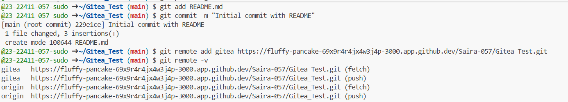

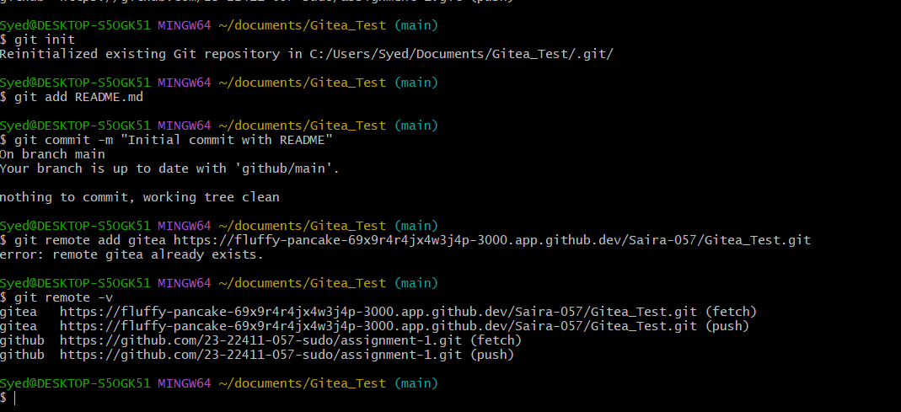
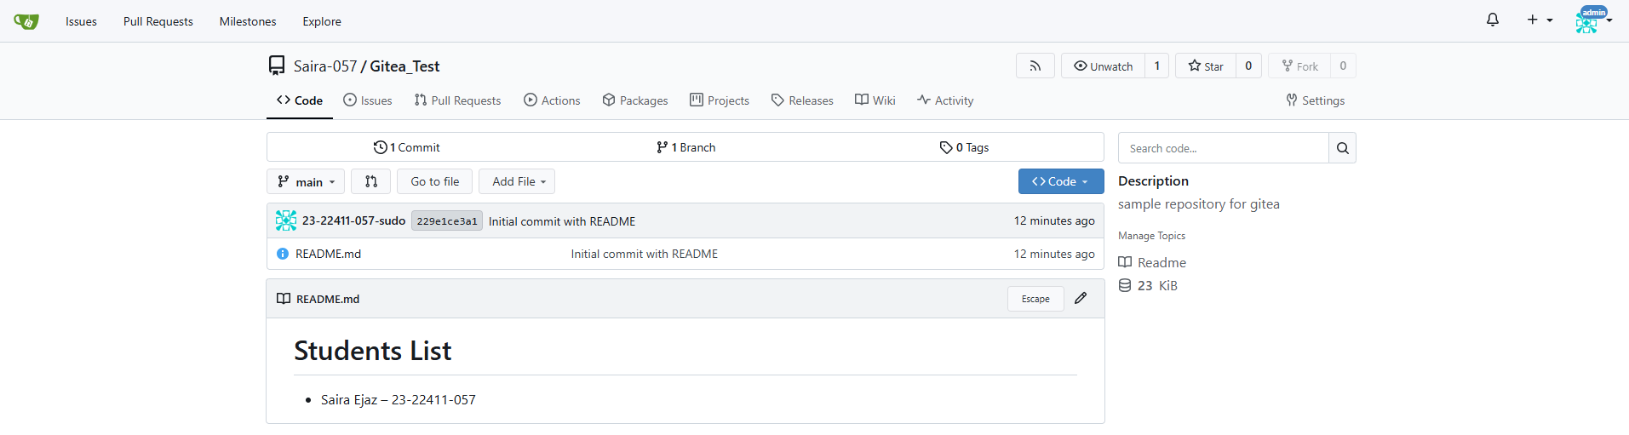
Gitea Server connection with Git Bash
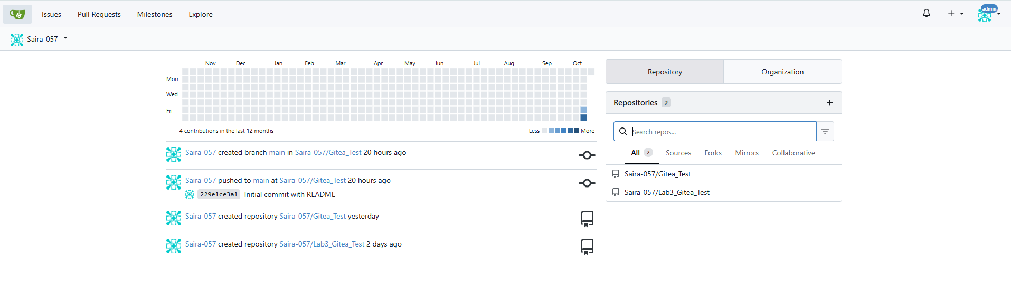
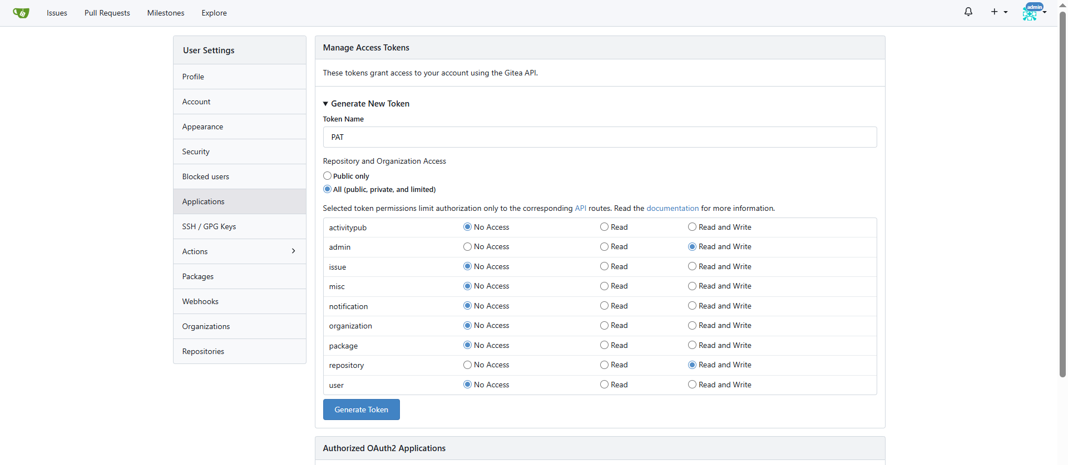
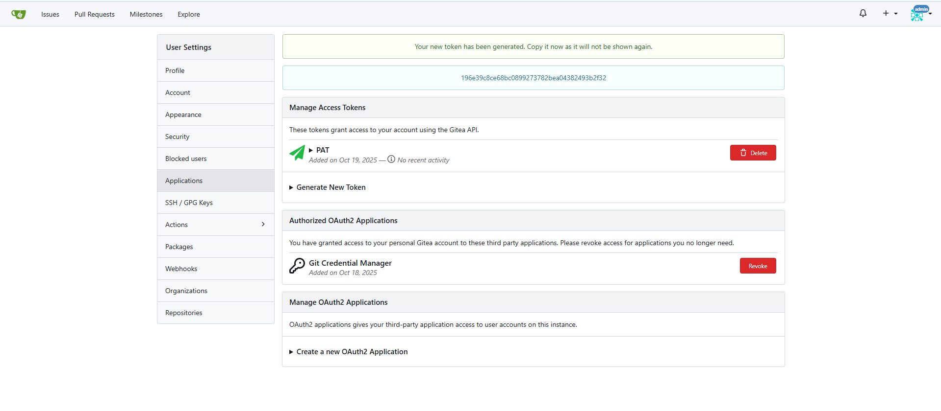
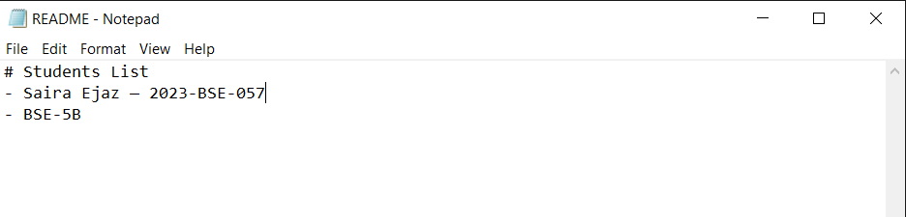
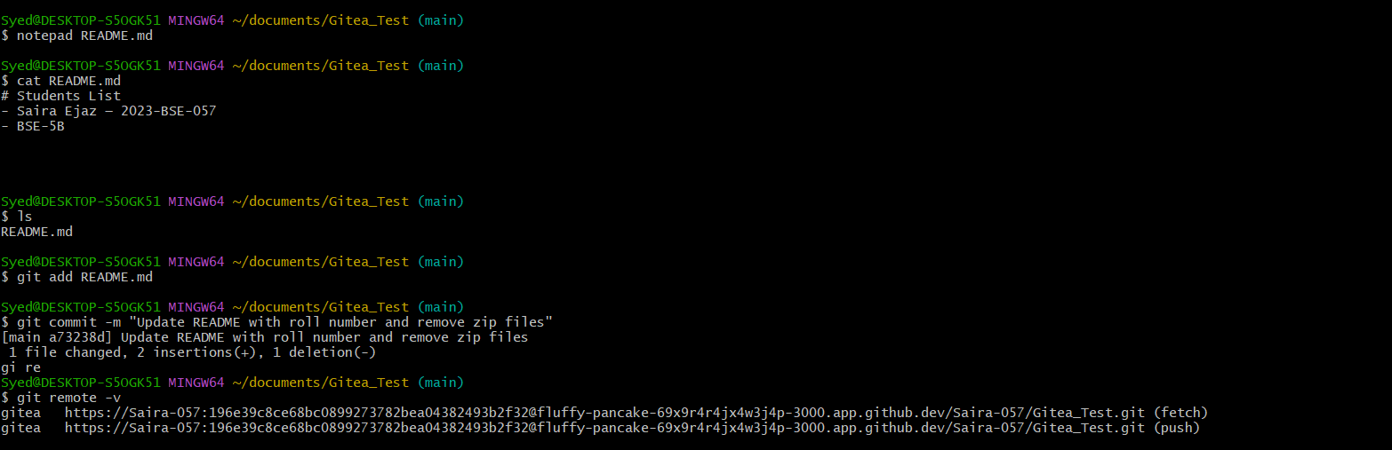
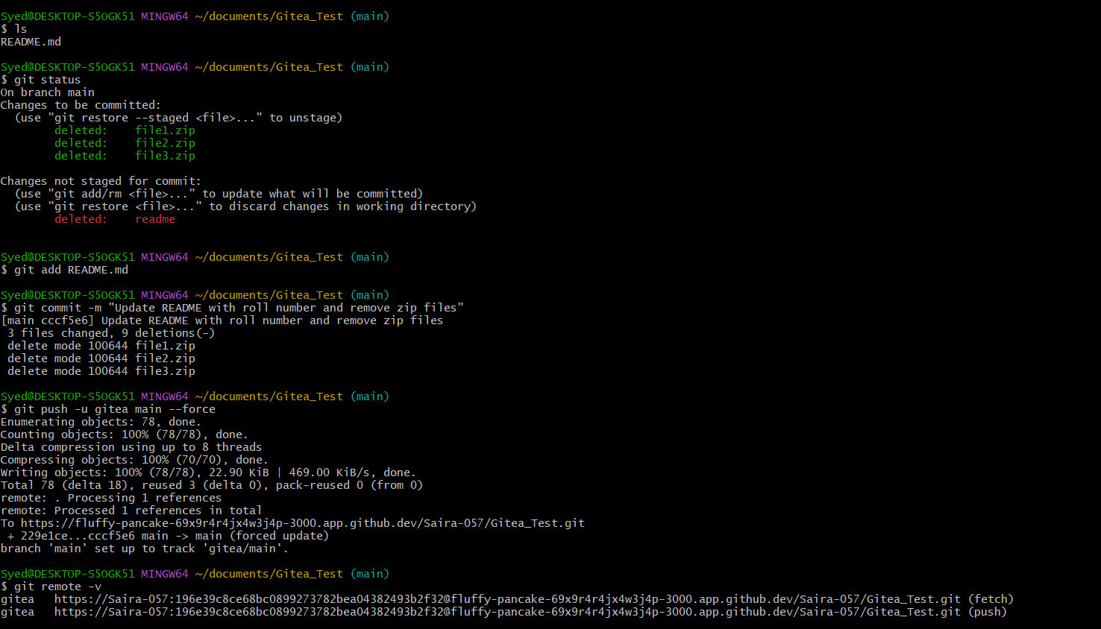
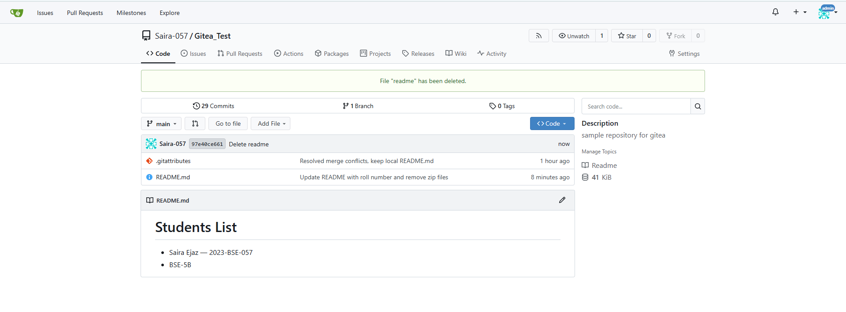
https://fluffy-pancake-69x9r4r4jx4w3j4p-3000.app.github.dev/Saira-057/Gitea_Test/src/branch/main/
- Task no 2

Mirror README.md from Gitea to GitHub
1. Continue Working with Your Existing Repository:
• Use the same repository that you created and pushed to your Gitea server in Task 1.
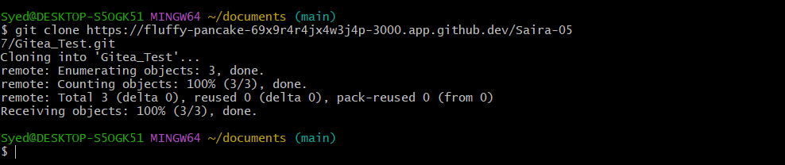
2. Create GitHub Repository:
• Create a new GitHub repository named assignment-1.
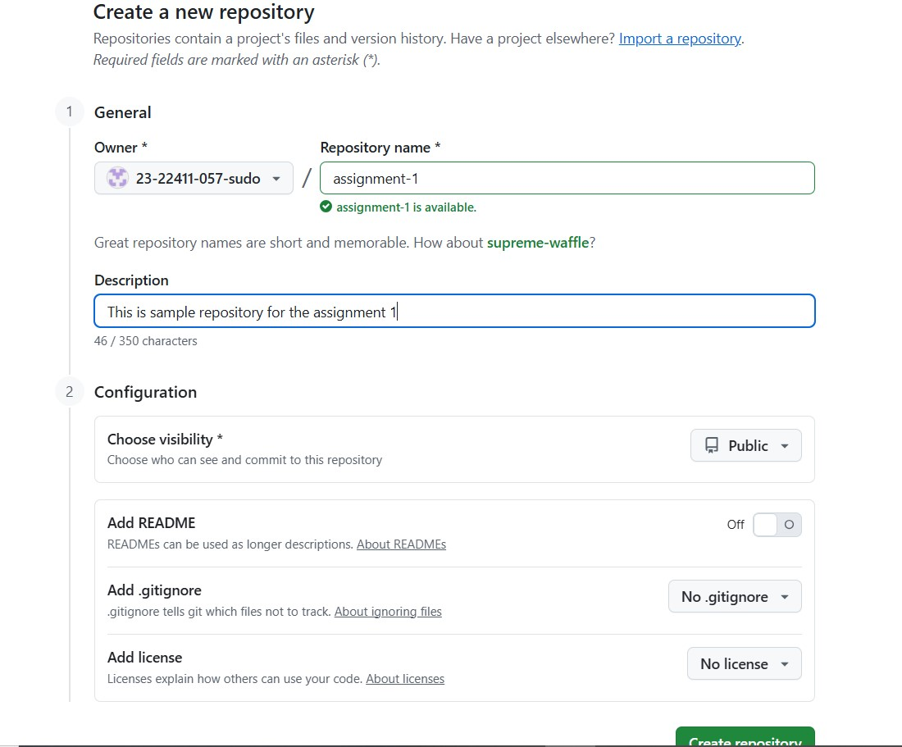

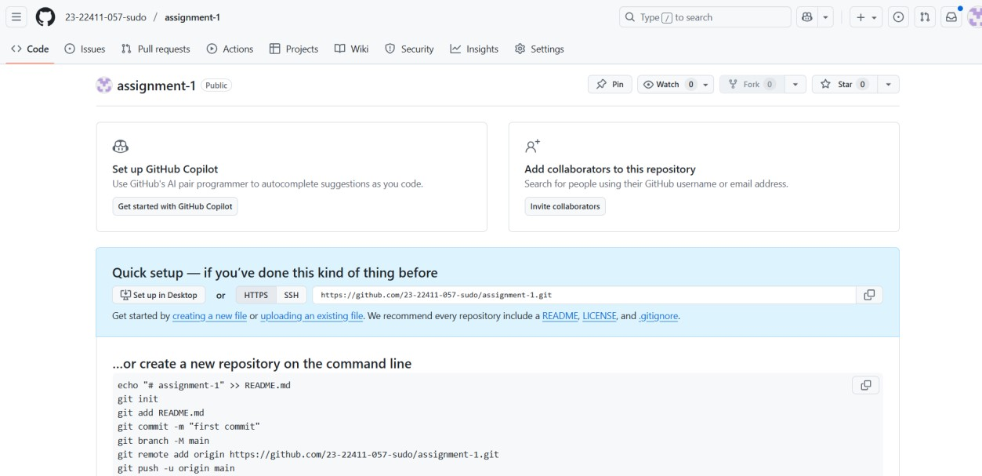
3. Add GitHub as a Second Remote:
- Add your GitHub repository as a remote to your local repository:
- git remote add github <your_github_repo_https_url>
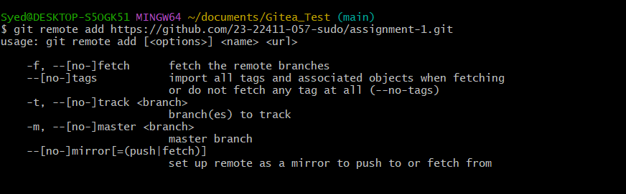
4. Push the README.md File to GitHub:
• Push the contents (including the README.md) from your local repository to GitHub. 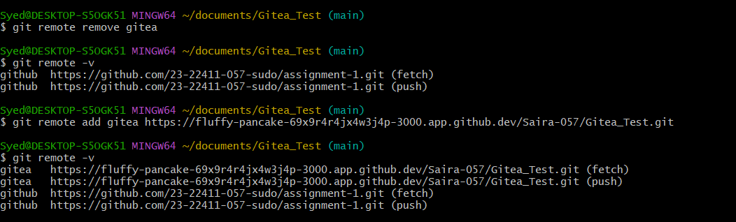
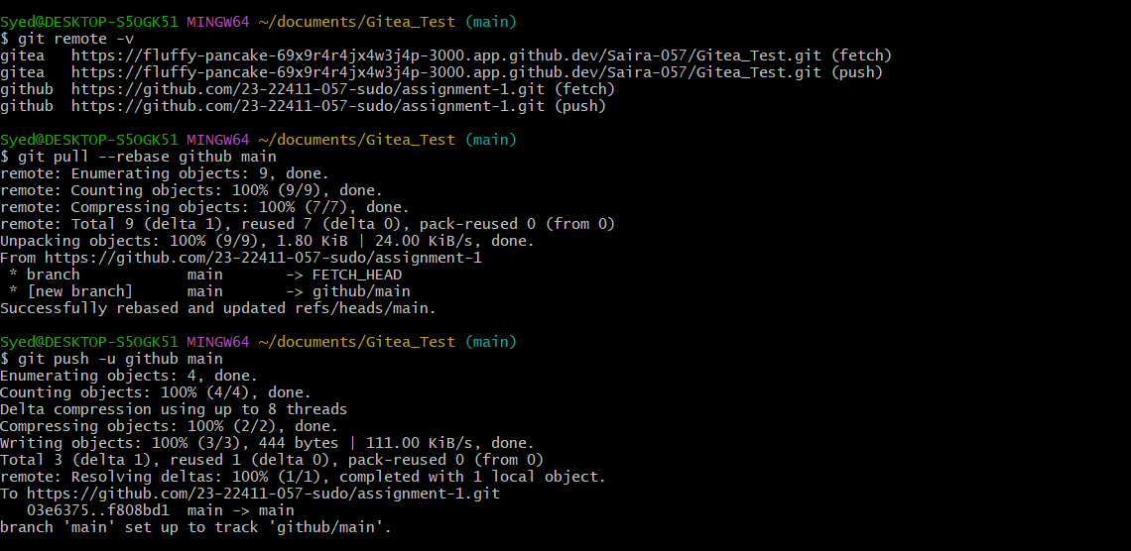
Readme.md from the lab repository in Gitea is pushed to assignment-1 repository in Github
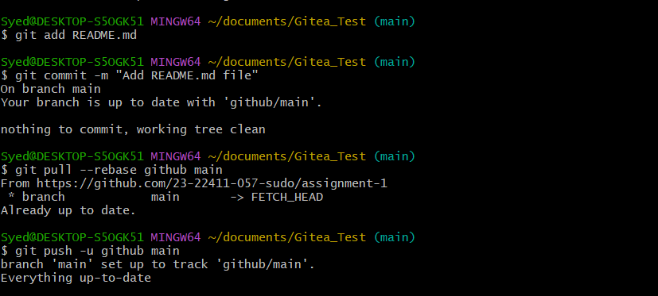
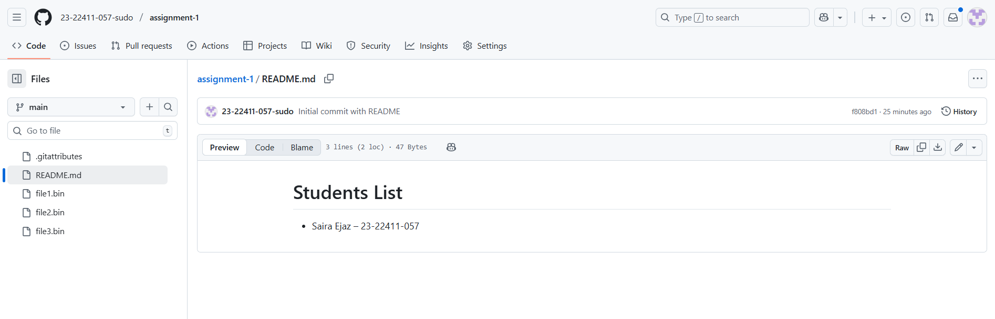
5. Verify Remotes:
• Run git remote -v and ensure both remotes (gitea and github) are listed.
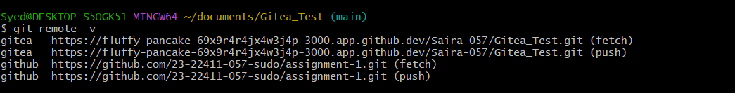

Task 3:

Use Git LFS for Large Files
https://github.com/23-22411-057-sudo/assignment-1
1. Install Git LFS:
• Set up Git LFS in your local repository.
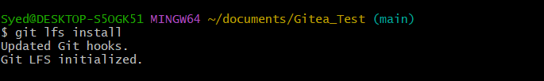
2. Add Large Files:
- Add three files larger than 100 MB each to your repository.
- Track them using Git LFS:
- git lfs track "*.ext"
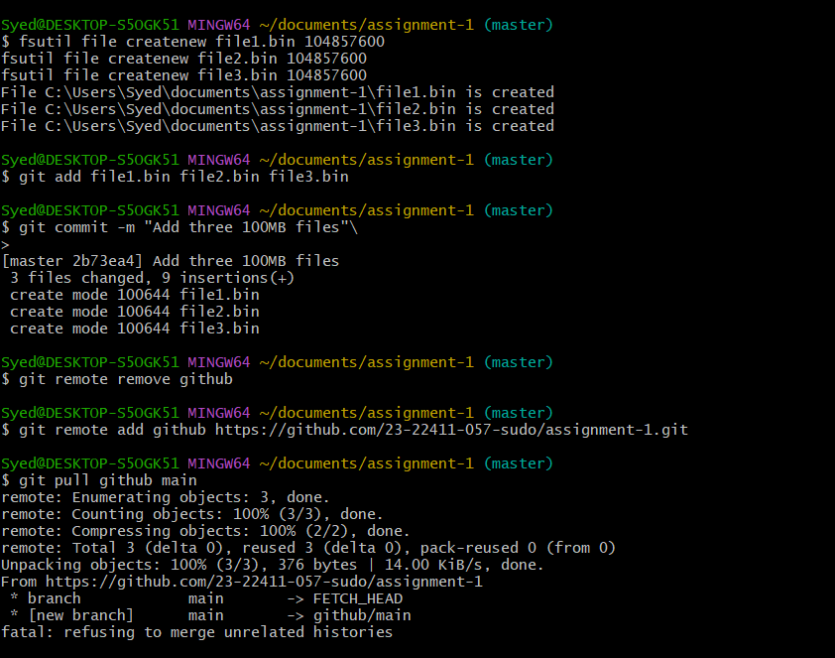
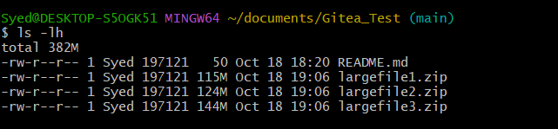
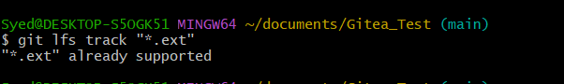
- Replace .ext with the appropriate file extension.
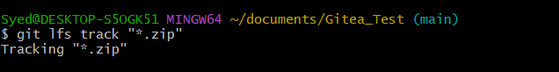
3. Reference in Assignment Repo:
- Commit and push these large files to your GitHub assignment 1 repo.
- Ensure the files are referenced correctly in your repository history.
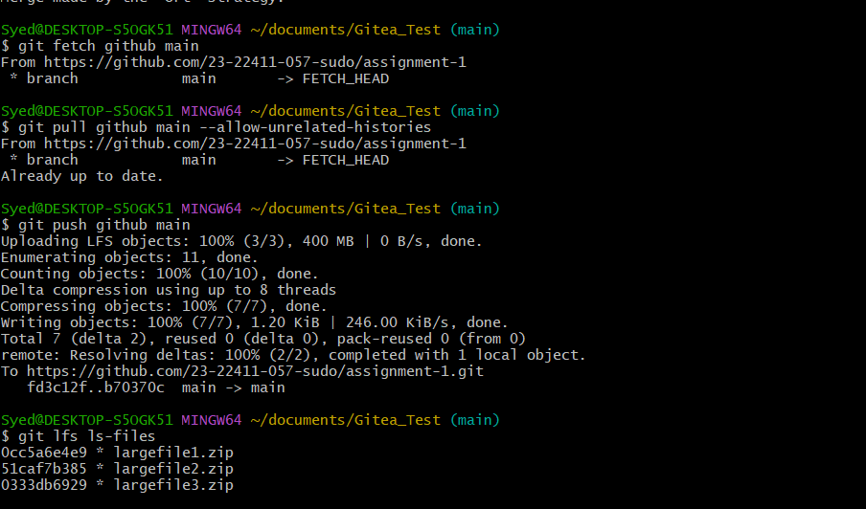
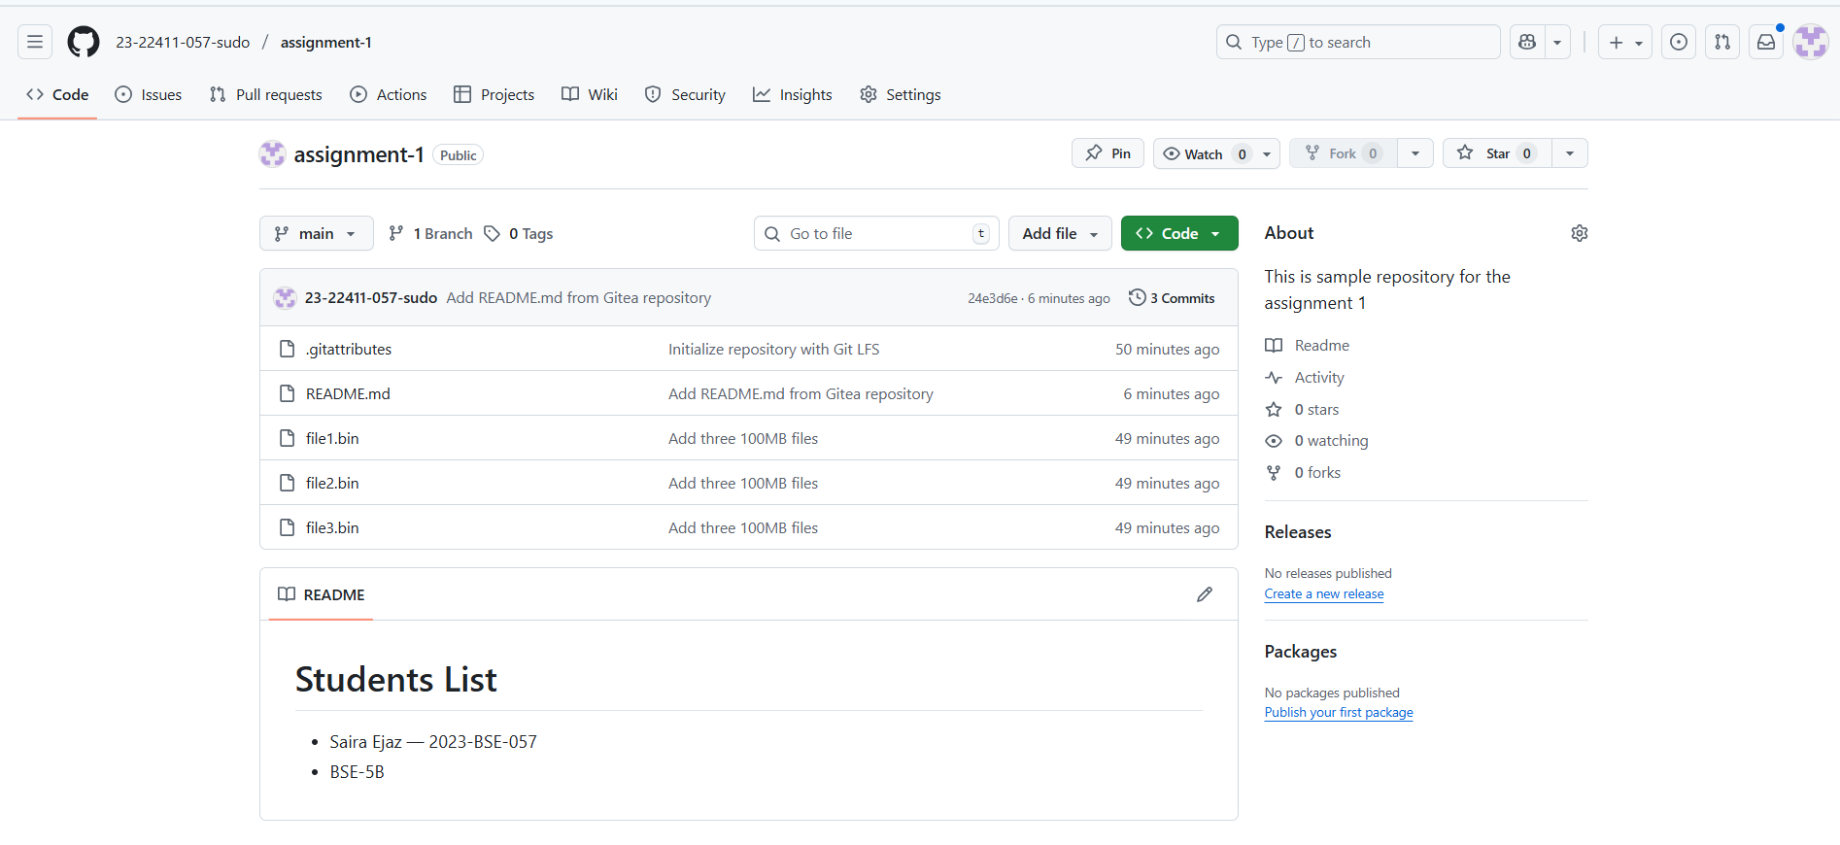
- Task 4:
Create a Portfolio/CV with GitHub Pages
1. Create a New Repository for GitHub Pages:
- Create a new repository named <your-username>.github.io.
- Replace <your-username> with your actual GitHub username (e.g., johnsmith.github.io).
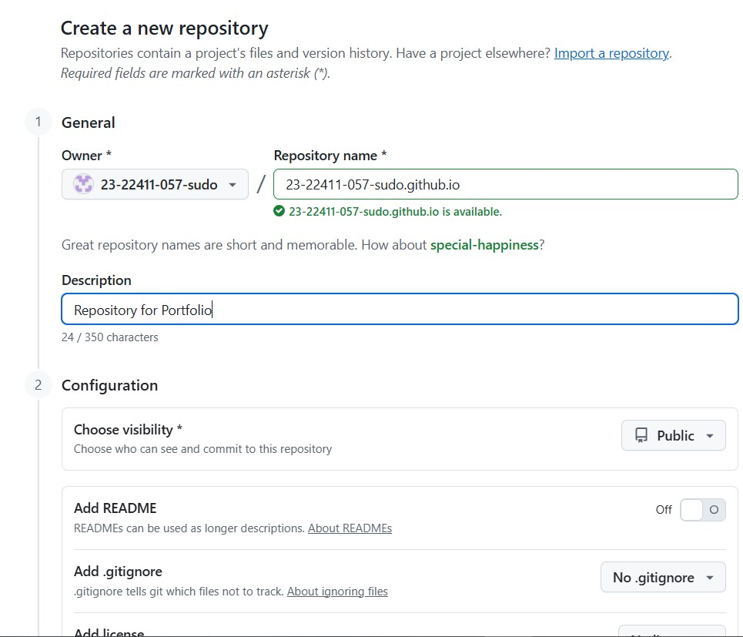

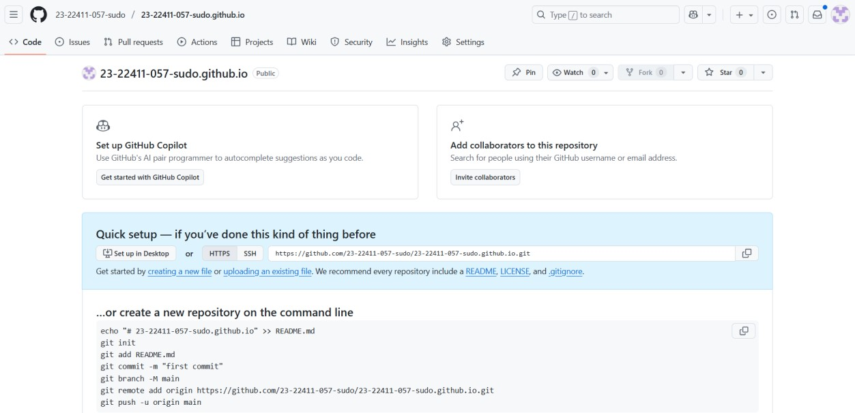
2. Design Your Portfolio/CV:
• Create your portfolio or CV in HTML/CSS (or use a static site generator).
3. Publish with GitHub Pages:
• Push your portfolio/CV files to the <your-username>.github.io repository.
Commands to push files for portfolio:
cd ~/documents/portfolio
git init git add .
git commit -m "Add new dark-themed portfolio (index1.html & style1.css)" git remote remove origin git remote add origin https://github.com/23-22411-057-sudo/23-22411-057sudo.github.io.git git branch -M main git push -u origin main
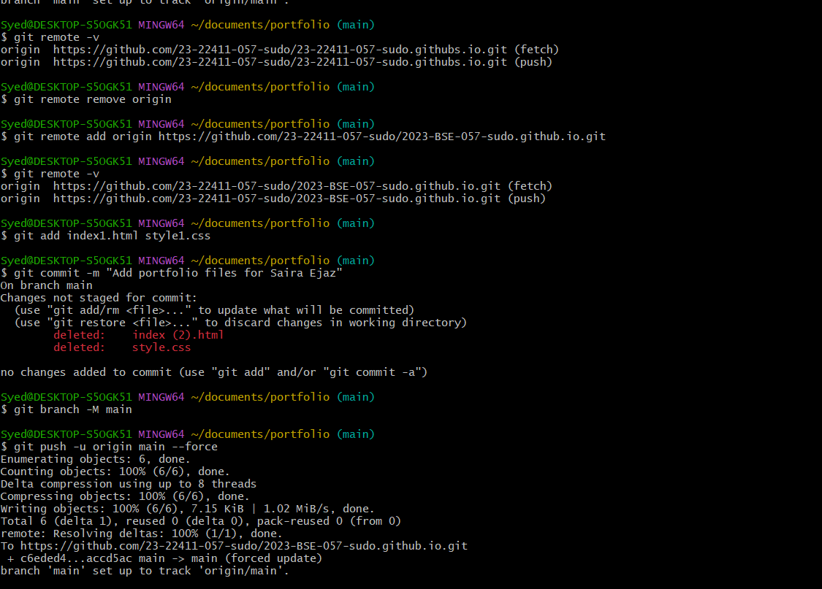
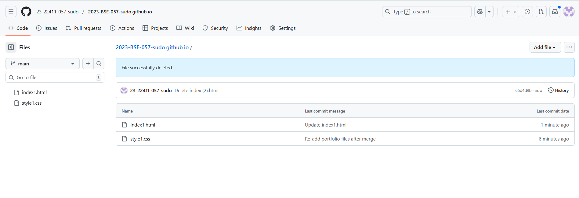

Enable GitHub Pages in your repository settings (if not automatically enabled).
- Publish your site and share the link.

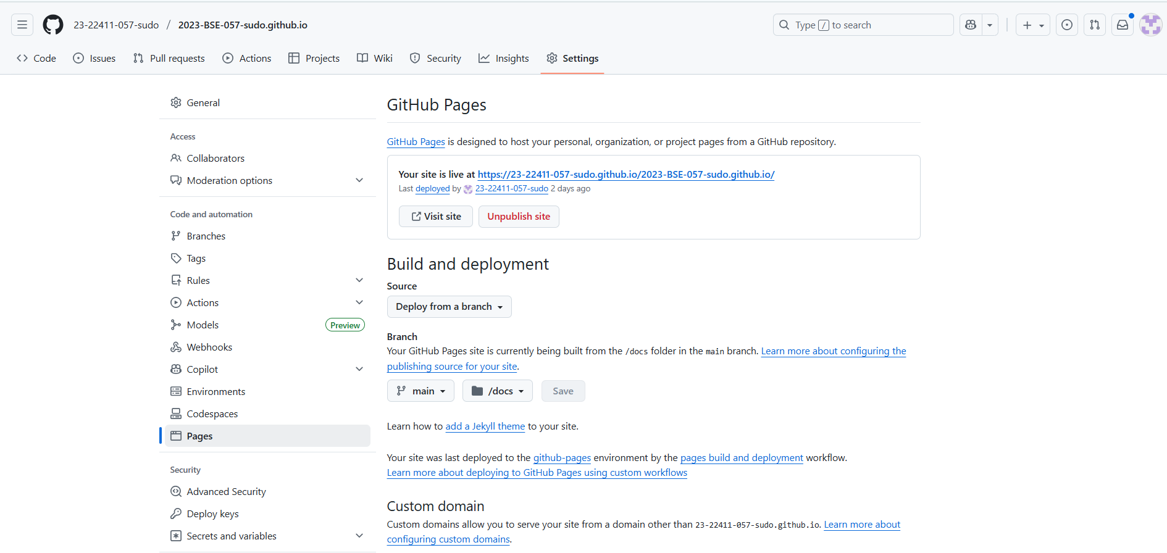

Publish your site and share the link.
https://23-22411-057-sudo.github.io/2023-BSE-057-sudo.github.io/
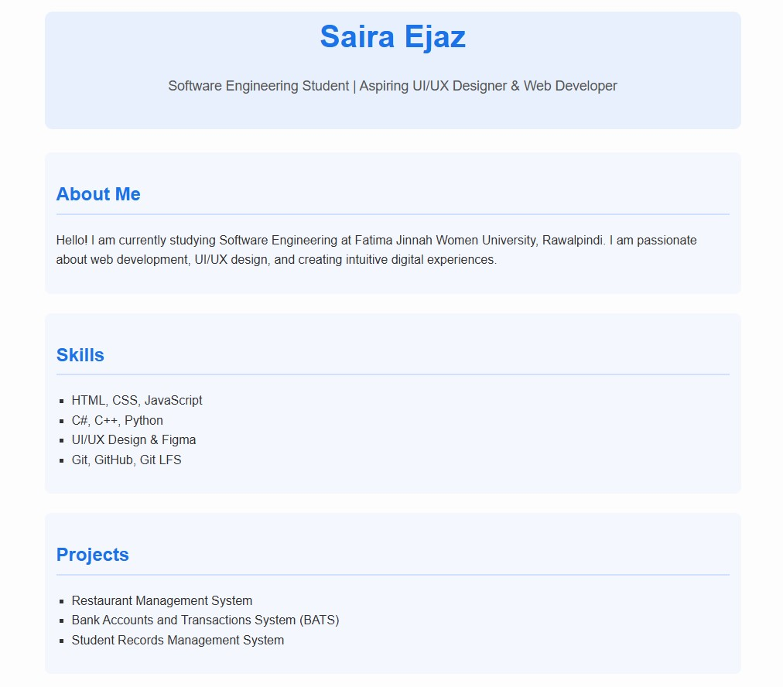
- Submission Checklist
- Screenshot of your Gitea repository (showing README listing names & roll numbers)

- GitHub assignment 1 repo link (with README and large files)
- https://github.com/23-22411-057-sudo/assignment-1

- Screenshot or output of git remote -v showing both remotes

GitHub Pages link to your CV/portfo https://23-22411-057-sudo.github.io/2023-BSE-057-sudo.github.io/
https://silver-eureka-5g7g4x4xw777cj5p-3000.app.github.dev/Saira12/lab

